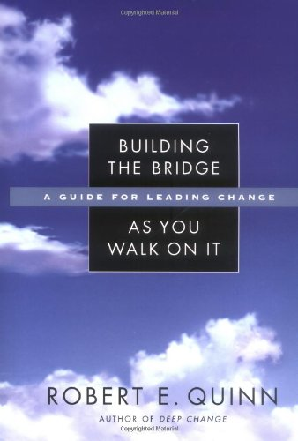 | Robert Quinn. Building the Bridge as You Walk On It A Guide for Leading. San Francisco, CA: Jossey-Bass, 2004.

A book of stories of leaders who are transformative. Collectively Quinn proposes they demonstrate the following characteristics:

Reflective action
Authentic engagement
Appreciative inquiry
Grounded vision
Adaptive confidence
Detached interdependence
Responsible freedom
Tough love

