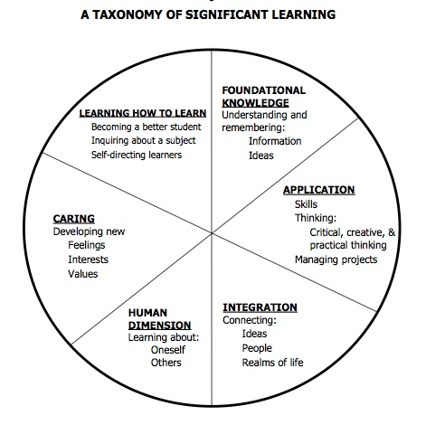
Taken from : L. Dee Fink (2003). Creating Significant Learning Experiences: An Integrated Approach to Designing College Courses. (San Francisco, CA: Willey & Sons Publishing), p 30.

