Fluency21- Five Fluencies for Global Digital Citizens
Solution Fluency
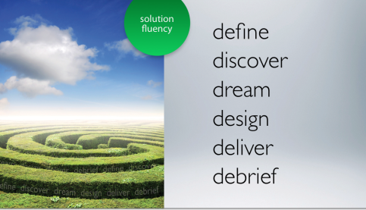

Our education system has taught problem-solving in a show-and-tell manner (we show students the problem, and tell them how we got the answer) that has fostered a culture of dependency, rather than discovery. But if you look at today’s economy, you’ll discover that most left-brain tasks are already automated or outsourced via Internet in a global economy, leaving jobs that require whole-brain thinking. This means creativity and problem-solving applied in real time. The 6D system is a logical, thorough, and relevant approach for tackling problems:!”
- Define the problem, because you need to know exactly what you’re doing before you start.
- Discover a solution, because planning prevents wasted effort.
- Dream up a process, one that is suitable and efficient.
- Design the process in an accurate and detailed action plan.
- Deliver by putting the plan into action by both producing and publishing the solution.
- Debrief and foster ownership by evaluating the problem solving process.
8
Information Fluency
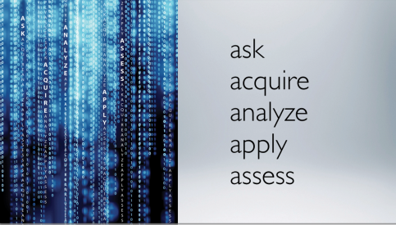

Because of InfoWhelm, data is increasing dramatically, facts are becoming obsolete faster, and knowledge built on these facts is less durable. Information fluency is the ability to unconsciously interpret this avalanche of data in all formats, in order to extract the essential and perceive its significance. Information fluency has 5 As, which are:
- Ask good questions, in order to get good answers.
- Access and acquire the raw material from the appropriate digital information sources, which today are mostly graphical and audiovisual in nature.
- Analyze and authenticate and arrange these materials, and distinguish between good and bad, fact and opinion. Understand bias and determine what is incomplete to turn the raw data into usable knowledge.
- Apply the knowledge within a real world problem or simulation using a VIP action (vision into practice).
- Assess both the product and the process, which is both a teacher and a student practice.
8

Creativity Fluency
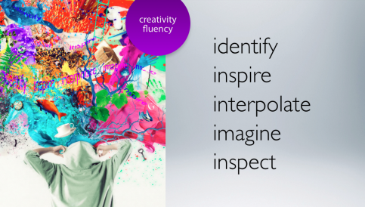

Creativity fluency how artistic proficiency adds meaning through design, art, and storytelling. We are all creative people. This means that creativity can be taught and learned like any other skill. It’s a whole brain process that involves both hemispheres working together. There are 5 Is to Creativity fluency:
- Identify the desired outcome and criteria.
- Inspire your creativity with rich sensory information.
- Interpolate and connect the dots by searching for patterns within the inspiration that align with your desired outcome and criteria from Identify.
- Imagine is the synthesis of Inspire and Interpolate, uniting in the birth of an idea.
- Inspect the idea against the original criteria and for feasibility.
8

Media Fluency
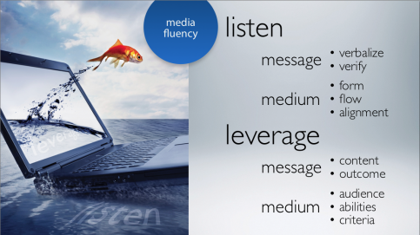

In our multimedia world, communication has moved far beyond the realm of text. Our visual learning capacity needs stimulation with rich media from a variety of different sources. But it’s more than just operating a digital camera, creating a podcast, or writing a document. There are two components of Media fluency—one forinput and one for output.
- Listen actively and decode the communication by separating the media from the message, concisely and clearly verbalizing the message and verifying its authenticity, and then critically analyzing the medium for form, flow, and alignment with the intended audience and purpose.
- Leverage the most appropriate media for your message considering your content or message and what the desired outcome is. Then consider the audience, your abilities, and any pre-determined criteria. From here, the application of the other fluencies is used to produce and publish your message.
8

Collaboration Fluency
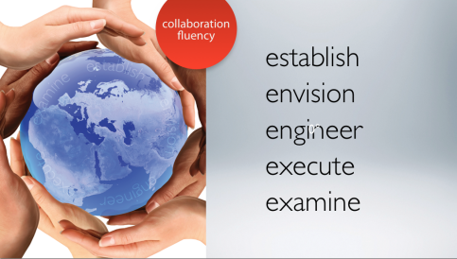

More and more, working, playing, and learning in today’s digital world involves working with others. It is the spirit of collaboration that will stimulate progress in our global marketplace, in our social networks, and in our ability to create products of value and substance. Collaboration fluency is the ability to successfully work and interact with virtual and real partners. The 5 Es of Collaboration fluency are:
- Establish the collective, and determine the best role for each team member by pinpointing each team member’s personal strengths and expertise, establishing norms, and the signing of a group contract that indicates both a collective working agreement and an acceptance of the individual responsibilities and accountability of each team member.
- Envision the outcome, examining the issue, challenge, and goal as a group.
- Engineer a workable plan to achieve the goal.
- Execute by putting the plan into action and managing the process.
- Examine the process and the end result for areas of constructive improvement.
8

Global Digital Citizen
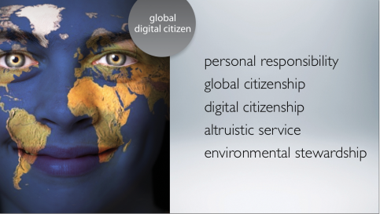
8
The digital citizen uses the principles of leadership, ethics, accountability, fiscal responsibility, environmental awareness, global citizenship, and personal responsibility, and considers his or her actions and their consequences. The ideal Global Digital Citizen is defined by the presence of 5 main qualities:
- Personal Responsibility in ethical and moral boundaries, finance, personal health and fitness, and relationships of every definition.
- Global Citizenship and its sense of understanding of world-wide issues and events, respect for cultures and religions, and an attitude of acceptance and tolerance in a changing world.
- Digital Citizenship and the guiding principles of respecting and protecting yourself, others, and all intellectual property in digital and non-digital environments.
- Altruistic Service by taking advantage of the opportunities we are given to care for our fellow citizens, and to lend our hands and hearts to these in need when the need is called for.
- Environmental Stewardship and its common sense values about global resource management and personal responsibility for safeguarding the environment, and an appreciation and respect for the beauty and majesty that surrounds us every day.

